Linear Regression and Logistic Regression
Linear Regression predicts continuous numerical values (e.g., house prices) by fitting a straight line, while Logistic Regression predicts categorical outcomes (e.g., yes/no spam detection) using a sigmoid curve to determine probability. Linear regression uses ordinary least squares, whereas logistic regression relies on maximum likelihood estimation to determine relationships.
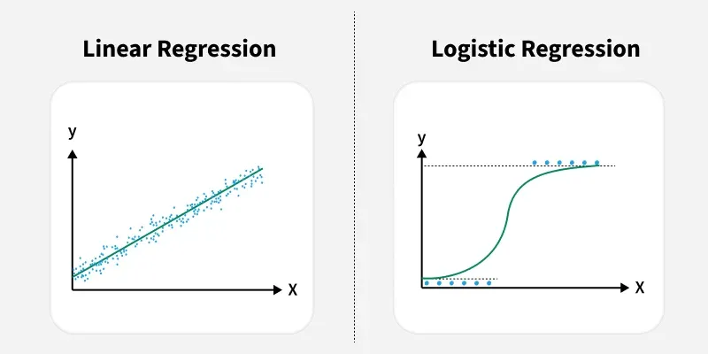

Linear Regression
- Purpose: Predicts a continuous output based on independent variables.
- Formula: y = mx + c (straight-line equation).
- Outcome: Numerical, ranging from negative to positive infinity.
- Example: Predicting temperature, sales, or test scores.

Logistic Regression
- Purpose: Predicts a categorical (binary) outcome using a probability between 0 and 1.
- Formula: Uses the logit function or sigmoid function 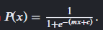
- Outcome: Class labels (e.g., 0/1, True/False, Spam/Not Spam).
- Example: Classifying disease vs. no disease, customer churn, or fraud detection.

Key Differences
- Output Type: Linear deals with Continuous numeric values; Logistic deals with Binary categorical data.
- Goal: Linear regression fits a straight line; Logistic regression fits an "S" shaped sigmoid curve.
- Evaluation: Linear uses Mean Squared Error (MSE) or R²; Logistic uses accuracy, precision, or log loss.

When to Use Which
- Linear Regression: Use when predicting a numerical amount, like estimating revenue for the next quarter.
- Logistic Regression: Use when deciding between two or more categories, such as determining if a transaction is fraudulent

